Dalec User Documentation

Introduction

What is Dalec?
Dalec, or “Distributed Annotation with Lazily Evaluated Computation”, is a system for performing ‘on-the-fly’ sequence annotations across DAS protocols, without the need for expensive precomputation of data. Novel Taverna workflows can be designed and exposed within a DAS server, and results can be acquired externally using the DAS protocol.

How do I use Dalec to expose a Taverna Workflow?
Once a workflow has been designed in Taverna, it can be saved as a .xscufl format file. Dalec can take saved workflows in files of this format, and execute queries against a workflow enactor instance, using as inputs queries submitted across the DAS server. The results of this workflow get stored in a locally held, “file store” database, and can later be retrieved from the DAS system.
This means that once you have the Dalec system installed and running, you can design different workflows, add them into the Dalec system, and expose them to DAS clients available on the web. This allows users to analyse their data using your pre-designed workflows. Using existing systems, users would have to access a database of sequences which have used your workflow to precalculated all the required annotations.

Minimum Requirements for Dalec
Dalec is designed to act as a DAS server for Taverna workflows. It is built in Java, so Java (JVM 1.4 or later) must be installed.
To run Dalec, your system must have a servlet container installed (Dalec has only been tested with Apache Tomcat, so this is recommended). Although not absolutely necessary, it is highly recommended that Apache Ant is installed on the system which will be running Dalec. Support for automation of configuration and deployment is provided by Dalec, some of which is dependent on having Ant installed – without Ant, some of the tasks must be performed manually.
Finally, once running, Dalec outputs its results to a local file store, so adequate hard disk space should be available on the local machine and write permissions granted if necessary.

Further Information
Dalec is built on top of Taverna for the workflow enactor, and the Dazzle DAS server package. For more information on Taverna, see http://taverna.sourceforge.net. Details on Dazzle can be found at http://www.biojava.org/dazzle.

Installation
Dalec can be downloaded from http://taverna.sourceforge.net/dalec (or something!). There is a windows installer binary available, or a skeleton webapp directory can be downloaded. Alternatively, the project can be built from source.
Prerequisites for Dalec include a web servlet container (Apache Tomcat), and Apache Ant. The TOMCAT_HOME environment variable should be set, as this will be used to determine where Dalec needs to be deployed, and the PATH variable should contain the path to Ant. With both of these set, it is easy to deploy Dalec once installation is complete. If not, configuration can take slightly longer, so it may be sensible to download the skeleton webapp structure.
Dalec can be configured without Ant, however it is more straightforward if Ant is installed as configuration and deployment can be handled automatically,

Windows
There is a windows installer available for download - download Install-dalec-1.0.exe and then run this file to start the installer
Follow the prompts to complete the installation. If you have Ant installed, the configurator utility can be used to configure every Dalec instance required. This is explained further below
Alternatively, you can download the skeleton webapp directory, packed as a .zip file. In this case, download the archive, extract all the files within. The configurator utility can then be run to setup Dalec, if Ant is installed.
You can build Dalec from source using the instructions, below.
For more details on configuring Dalec once installation has completed, please see the following section “Basic Configuration”.

UNIX
Download the archived skeleton webapp directory structure from (wherever!!), dalec-1.0.tag.gz. Extract all files to the installation directory and run the configurator utility to set it up (if Ant is installed).
Alternatively, you can build Dalec from source. See the instructions below

To Build from Source
If you wish to build the application from source, the dalec module can be checked out from the Taverna CVS repository, hosted at sourceforge.net. You can use:
cvs -d:pserver:anonymous@cvs.sourceforge.net:/cvsroot/taverna login
cvs -z3 -d:pserver:anonymous@cvs.sourceforge.net:/cvsroot/taverna co -P Dalec
Once you have acquired the source, the project can be built using Ant with the supplied build.xml file. All required Jars will be retrieved during this process.

Getting Started

Basic Configuration
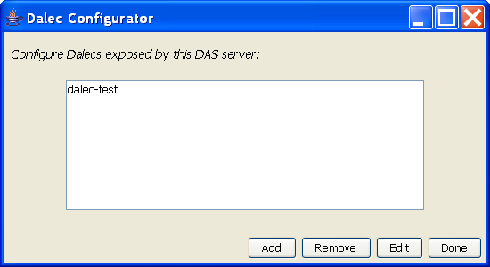
Unless you have chosen to download a skeleton webapp directory, the Dalec configuration utility should start automatically once installation is complete (if not using Ant, please see Advanced Setup and Configuration).
The configuration utility is shown above. A single, running Dalec application can have several separate Dalec “datasources” – in other words, Dalec can expose several workflows on the DAS server. By clicking “Add”, a new window is opened to set individual details for this datasource.
Figure 1 - the Dalec Configurator utility
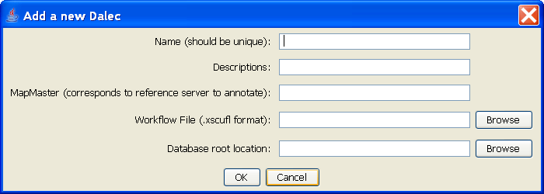
Figure 2 - The Add window of the Configurator
The details for this datasource should be set in this window. Every Dalec “datasource” must have set the properties shown in this window. A further discussion of these attributes follows. Once you have set some attributes for your datasource, click OK to accept them. You can then either add another new Dalec, edit an existing one, or click done to accept your changes.
- Name.
  - This should be unique, as it will be used as the identifier for the DAS server (where DAS URL requests take the form http://www.yourdomainname.com/das/name where “name” represents the name specified here).
- Description
  - An optional human readable description of this datasource
- MapMaster URL
  - A MapMaster URL tells an annotation source in DAS where to retrieve reference sequences from. The URL to a legitimate DAS reference server should be specified here. The full URL must be given, even if the reference serve is contained with the same webapp. Sequences can then be retrieved from the reference server on request, to be annotated.
- Workflow file
  - The workflow file that will be used to perform the annotations. This should be located on the local system.
- Database root location
  - A root directory location in which to store generated GFF files which contain the annotation results. Again, this should be held on the local system. If this directory does not exist, it will be created by Dalec.
Once completed, the Dalec details should look something like this:
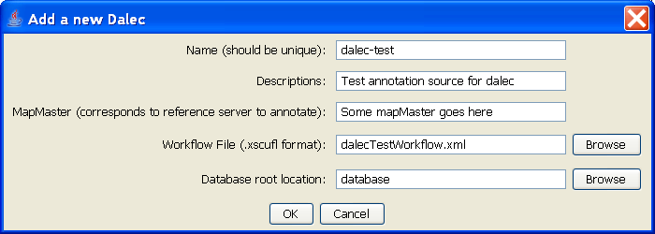
Figure 3 - a sample completed Dalec datasource

Deployment
If you are using Ant, once you click done on the configurator utility, the Dalec application will be automatically packaged into a war file (by convention, this will be called das.war) and dropped into the webapps directory of your Tomcat installation (assuming $TOMCAT_HOME is set). If you already have an existing DAS server running and das.war already existed, the Dalec structure will be added to the existing das.war file, allowing existing services to be supplied. The old das.war file is stored as das.old in the deployment directory of Dalec.
Once this completes, simply restart Tomcat and Dalec should now be available.
If you are NOT using Ant and you have run the configurator utility manually, you must now package the dalec-webapp directory into das.war and copy it into Tomcat. More details on this are given below (see Advanced Setup and Configuration).

Usage
Once the installation is complete and Tomcat restarted, queries should be able to be submitted to the DAS server as you would normally expect.
The configurator utility can be run at any time. If it’s executed using the executable jar file configUI.jar, it will simple edit the dazzlecfg.xml file found in the $DALEC_HOME\dalec-webapp directory. If you run it using the setup.bat file from windows, or the setup script from UNIX, and you have Apache Ant installed, the updated webapp will automatically be redeployed into Tomcat. Simply restart Tomcat for the changes to take effect.

Designing Workflows for Dalec
Dalec will deploy any Taverna workflow which conforms to a couple of basic requirements. As Dalec is a system for annotating Amino Acid sequences and returning this annotation data, your workflow must perform these functions. To this end, your workflow should accept either sequence identifiers (which should correspond to the identifier used by the DAS reference server your workflow is designed to annotate) or the sequence itself. In the first case, the input processor should be named “seqID” to enable the enactor engine to identify the appropriate input. In the latter case, your input processor should be called “sequence”.
The output processor handles the data which is returned to Dalec from your workflow. Dalec creates GFF file entries for every annotated sequence. To achieve this, it is intended that all workflows designed for Dalec should return a GFF-XML formatted string. The output processor returning this data should be called “annotations”.
As long as these conditions are met, Dalec should handle all the transfer and parsing of data to and from the workflow enactor, automatically populating the database with the resulting annotations in standard GFF file format.

Advanced Setup and Configuration

Configuring to work with an existing DAS Server
If your system is already being used as a DAS server, there will probably be a das.war file already in the $TOMCAT_HOME/webapps directory. When you install Dalec, it will retrieve and preserve the existing libraries and classes found in this war file. The Dalec files will be added to the existing webapp. This means that Dalec should simply be integrated to work alongside any pre-existing DAS datasources you have exposed.
Dalec will overwrite any files which are packaged with Dalec – so for example, if the file dazzle.jar already exists in your Tomcat webapp library, it will be overwritten with the version used by Dalec. This may cause conflicts with existing sources. If you were previously using Dazzle as your DAS servlet, Dalec will actually import all existing datasources into the new dazzlecfg.xml file, so in most cases, further configuration will not be necessary. Otherwise, it is straightforward to import your old datasources into the new Dazzle installation. For more details on manual configuration of Dazzle, see http://www.biojava.org/dazzle.
If you previously had a das.war file which used a DAS server implementation other than Dazzle, conflicts may occur between the two systems. As Dalec itself contains an implementation of Dazzle, it is not recommended to attempt to use Dalec alongside another DAS server system. If you do wish to do this, you should rename one or other of the das.war files, although this is not normally recommended in DAS. Ideally, manually configure your system to use one type of server implementation. Whenever you are replacing an existing DAS server, you should always shut down the server first, delete any existing temporary files, and restart once the new das.war file has been copied in.
If a previous das.war file was found when Dalec was run for the first time, it will be saved as das.old in the Dalec \deployment directory.

Further Information

Extending Dalec

